**How to perform HTML to PDF conversion with external CSS in ASP.NET Core HTML file**

The Syncfusion® Essential PDF is a feature-rich and high performance[**.NET PDF library**](https://www.syncfusion.com/document-processing/pdf-framework/net) used to create, read, and edit PDF documents programmatically without Adobe dependencies. Using this library, you can perform HTML to PDF conversion with external CSS in HTML file using C#.

**Steps to perform HTML to PDF conversion with external CSS in HTML file programmatically:**

1. Create a new console application project.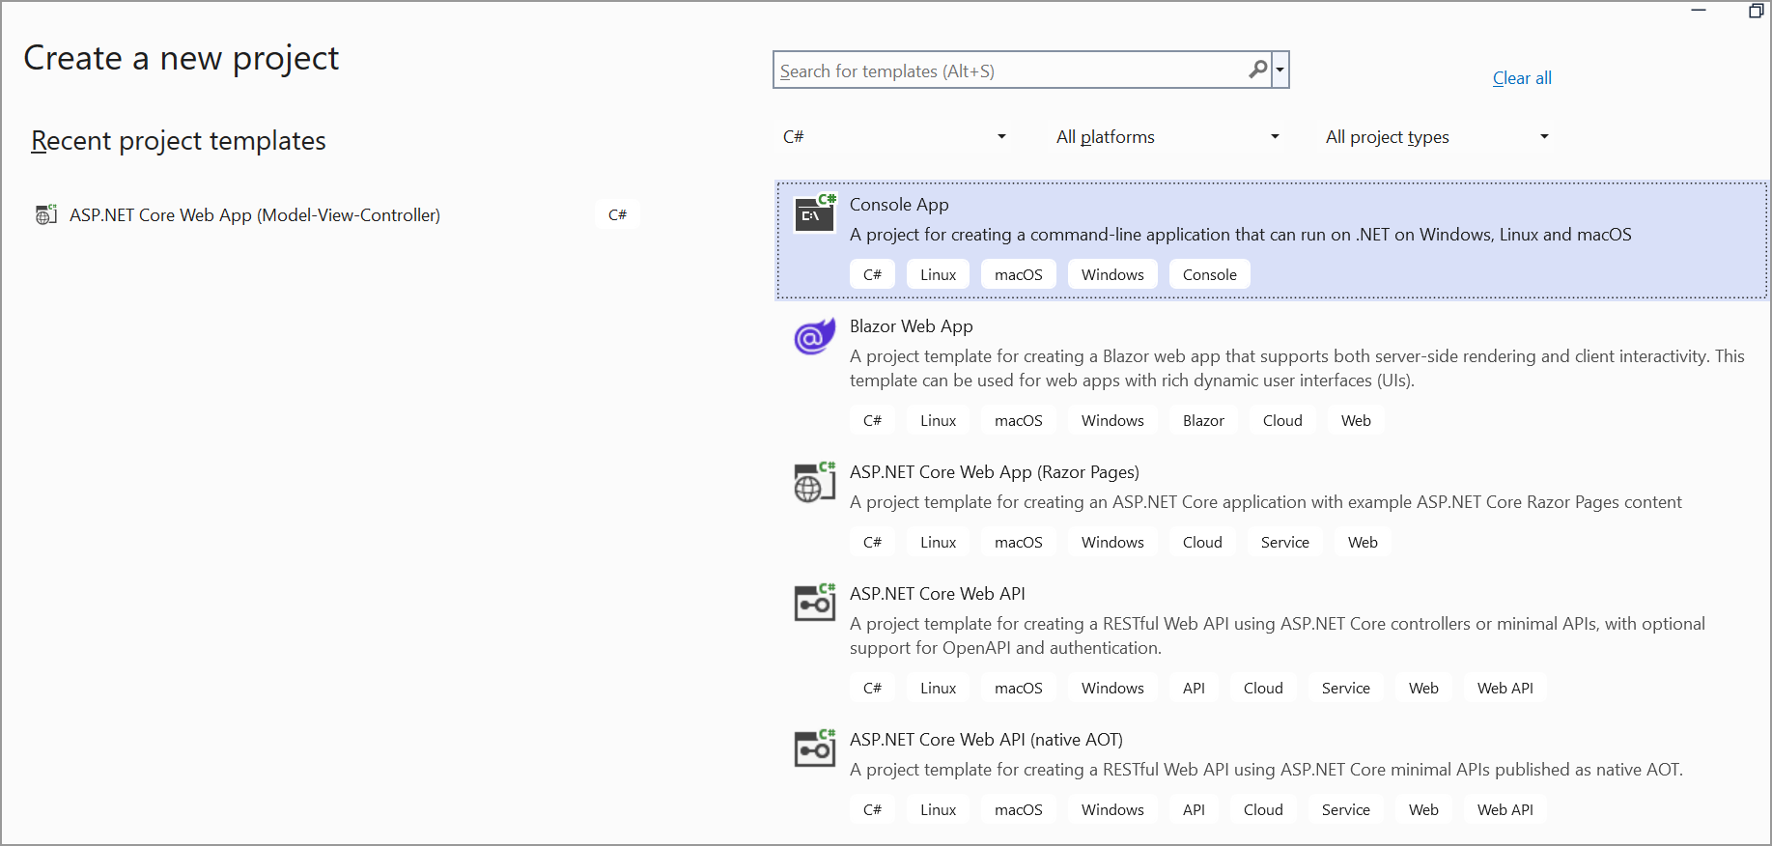
2. Install the **[Syncfusion.HtmlToPdfConverter.Net.Windows](https://www.nuget.org/packages/Syncfusion.HtmlToPdfConverter.Net.Windows" \t "_blank)** NuGet package as a reference to your console application from [**Nuget.org**](https://www.nuget.org/).

1. Include the following namespaces in the Program.cs file.

**C#**

using **Syncfusion**.HtmlConverter;

using **Syncfusion**.Pdf;

1. Use the following code sample in Program.cs to perform HTML to PDF conversion with external CSS in HTML file.

**C#**

//Initialize HTML to PDF converter

**HtmlToPdfConverter** htmlConverter = **new** **HtmlToPdfConverter**();

**BlinkConverterSettings** blinkConverterSettings = **new** **BlinkConverterSettings**();

blinkConverterSettings.Scale = 1.0f;

blinkConverterSettings.MediaType = **MediaType**.Print;

//Assign Blink converter settings to HTML converter

htmlConverter.ConverterSettings = blinkConverterSettings;

//Get HTML string from file

string html = **File**.**ReadAllText**(**Path**.**GetFullPath**("../../../Data/HtmlSample.html"));

//Get the resources path

string baseUrl = **Path**.**GetFullPath**("../../../Css/");

//Convert URL to PDF document

**PdfDocument** document = htmlConverter.**Convert**(html, baseUrl);

**if** (**File**.**Exists**("HTML-to-PDF.pdf"))

{

**File**.**Delete**("HTML-to-PDF.pdf");

}

//Create file stream

**MemoryStream** stream = **new** **MemoryStream**();

//Save the document into stream

document.**Save**(stream);

//If the position is not set to '0' then the PDF will be empty.

stream.Position = 0;

**File**.**WriteAllBytes**("HTML-to-PDF.pdf", stream.**ToArray**());

//Close the document

document.**Close**();

stream.**Dispose**();

A complete working sample can be downloaded from [**HTML\_to\_PDF\_with\_external\_CSS.zip**](https://www.syncfusion.com/downloads/support/directtrac/general/ze/HTML_to_PDF_conversion-1161801623.zip)

By executing the program, you will get the PDF document as follows.

Take a moment to peruse the documentation for [**Converting HTML to PDF**](https://help.syncfusion.com/file-formats/pdf/converting-html-to-pdf), where you will find various options for URL to PDF, HTML string to PDF, and Hyperlinks.

**Conclusion**  
I hope you enjoyed learning about how to perform HTML to PDF conversion with external CSS in [**ASP.NET**](http://asp.net/) Core HTML file.

You can refer to our [**ASP.NET Core PDF feature tour**](https://www.syncfusion.com/document-processing/pdf-framework/net-core) page to know about its other groundbreaking feature representations and [**documentation**](https://ej2.syncfusion.com/file-formats/pdf/getting-started), and how to quickly get started for configuration specifications. You can also explore our [**ASP.NET Core PDF example**](https://ej2.syncfusion.com/aspnetcore/Pdf/SalesInvoice#/bootstrap5) to understand how to create and manipulate data.

For current customers, you can check out our components from the [**License and Downloads page**](https://www.syncfusion.com/sales/teamlicense). If you are new to Syncfusion®, you can try our 30-day [**free trial**](https://www.syncfusion.com/downloads/aspnetcore-js2) to check out our other controls.

If you have any queries or require clarifications, please let us know in the comments section below. You can also contact us through our [**support forums**](https://www.syncfusion.com/forums/), [**Direct-Trac**](https://support.syncfusion.com/create), or [**feedback portal**](https://www.syncfusion.com/feedback/aspnet-core?control=pdf). We are always happy to assist you!